PROJECT REPORT

**IREVOLUTION:A DATA –DRIVEN EXPLORATION OF APPLE’S IPHONE IMPACT IN INDIA.**

**TEAM DETAILS:**

**TEAM LEADER: S.JANANI**

**TEAM MEMBERS: P.SUGASINI,M.RAFIYA THARIQ,S.SRI SANGAVI.**

**1.INTRODUCTION**

**1.1 Overview:**

**First I created an EMPATHY MAP. A map has four quardrants –says,thinks,does and feels.next.How do I prepare for tableau interview . How do you measure the talent management success.What are the critical issues that a talent scorecard should measure?this are all things I shown in my four quardrants .Next I created BRAIN STROM .My team members give some ideas for this brainstorm .then I created my data analysis _Dashboard and story Next I published my dashboard and story in the Tableau Public.**

**1.2 Purpose:**

**The purpose of the talent management is to identify ,recruit and hold on to people who drive the success of your organization. Performance and talent management is a key function of the modern HR deparment .Talent management HR also strives to keep existing employees and promote them to more crucial positions in the company.it saves money on high employee turnover.It makes much more sense to grow and retain necessary talent than sourching , hiring , and traing new ones.**

**2.Problem Definition & Design Thiniking**

**2.1 Empathy Map**

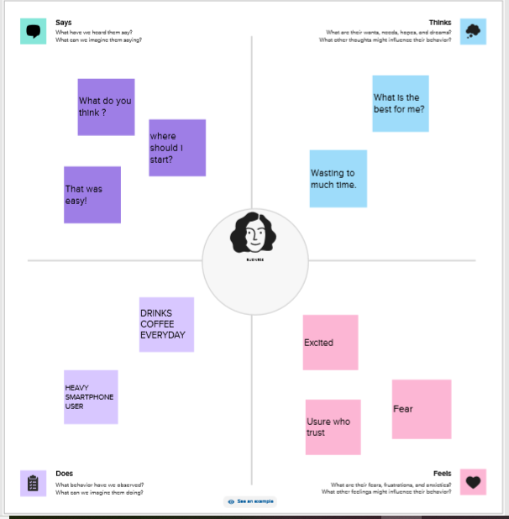

**2.2 Ideation & Brainstorming Map**

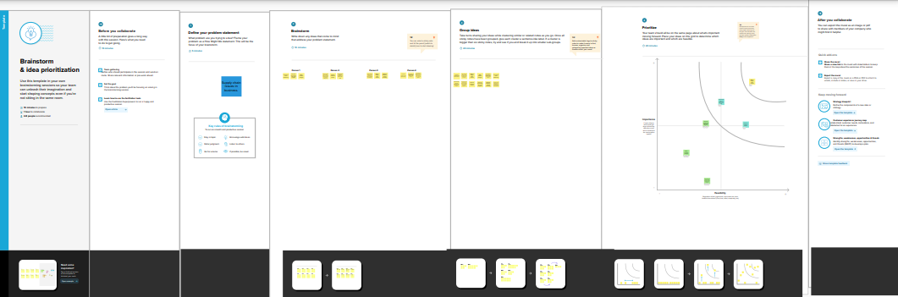

3 RESULT:

DASHBOARD:

Dashboard 1 :

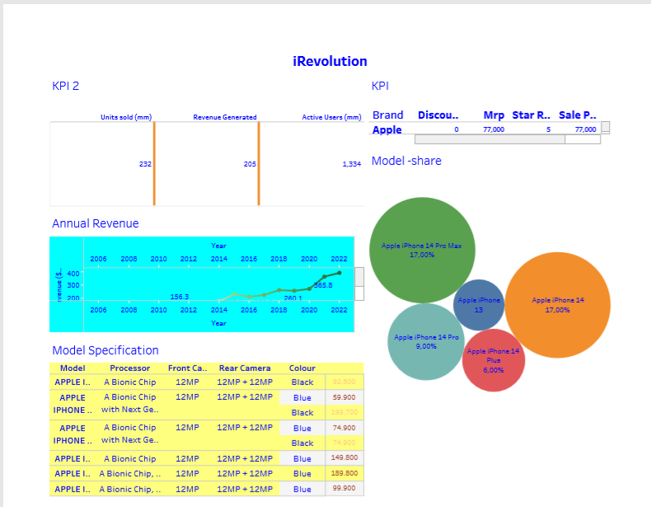

Dashboard 2 :

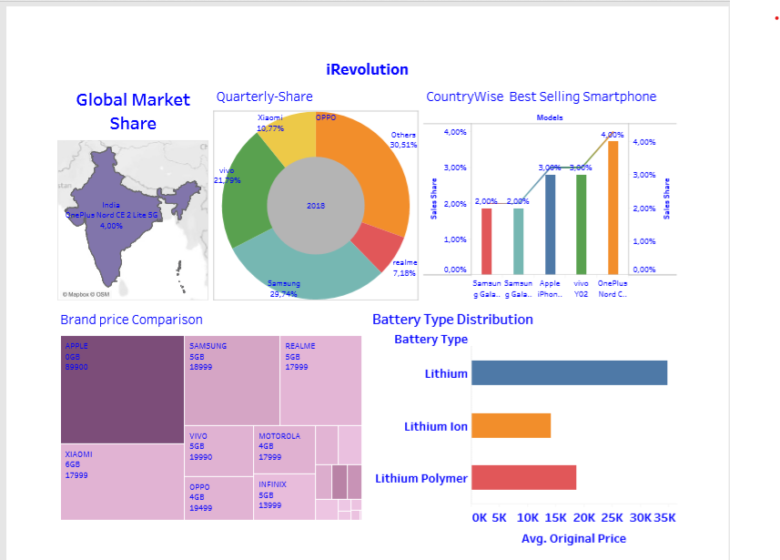

STORY:

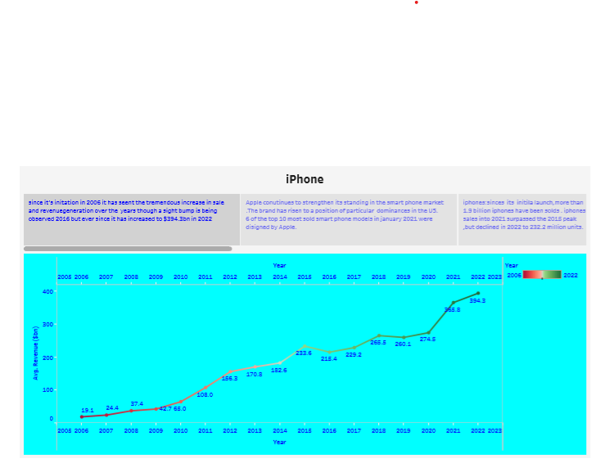

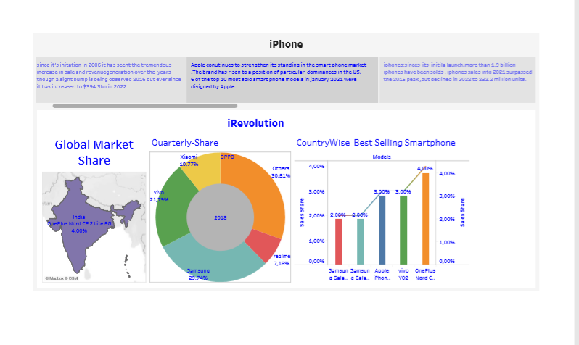

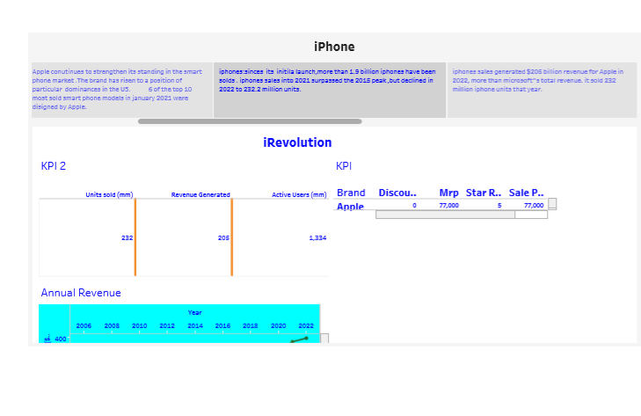

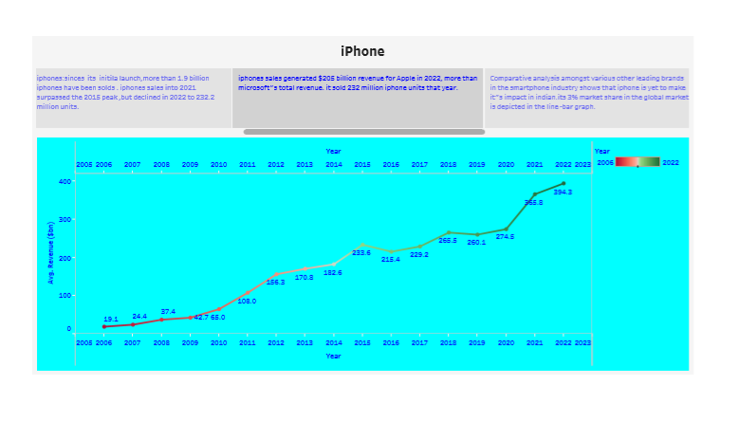

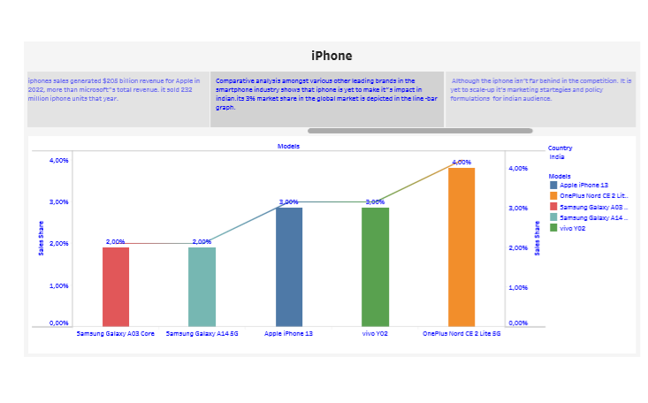

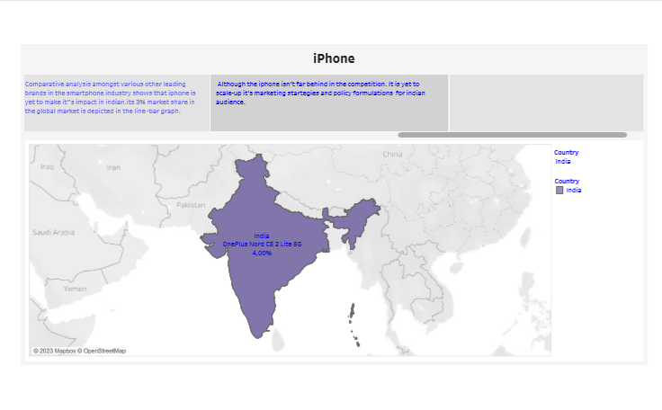

4 ADVANTAGES & DISADVANTAGES:

Advantage:

* Rich user experience.
* Less updates –less tests.
* Access to the leading markets.
* Fast development process.

Disadvantage:

* Expensive app development process and maintenance .
* Closed source OS.
* Time –consuming and laborious app store review.
* Volatile Apple’s market share

5 Applications:

A software application that runs under ios,Which is the operating system that powers Apple’s mobile devices.In most cases ,any application that runs on an iphone also runs on an ipad and ipod touch.

6 Conclusion:

It is apparent that the iphone was ,and still ,a remarkable invention of technological advancement The iphone provided a new way of mobile phone communication and usability .

Future Scope:

The most important part of the iphone might be everything around it .That’s according to analysts who’ve observed the mobile industrys general trends and Apple strategy .